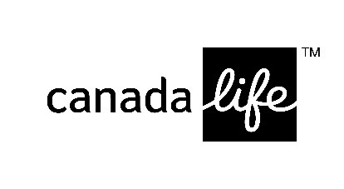
Group retirement plan

Payroll deduction authorization

To be completed by an employee who is eligible to participate in a group retirement plan.

EMPLOYER/PLAN SPONSOR INFORMATION
Name of employer/plan sponsor  WESTRIDGE ROCK VENTURES LTD. | Policy/plan number  74264
EMPLOYEE INFORMATION
Last name Initial First name | Social insurance number  - - | Employee I.D.

Payroll deduction authorization – I authorize my employer/plan sponsor to deduct contributions for remittance to the above plan as follows:

Plan: RRSP RPP Non-registered TFSA VRSP
Other

Payroll deduction: | Contribution Type |  | Amount to be deducted per pay
(fill in only those applicable) | Regular / required
 | Additional voluntary
This replaces all previous instructions for this group retirement plan.

Employee signature _____________________________________ Date

NOTE: This form is to be retained by the client/plan sponsor and should not be returned to Canada Life.

